Evaluating the Performance of a Signal Processor

Tom Brimeyer
NCAR/EOL/RSF
April 11, 2007

Overview

When working with signal processors, it is important to know what kind of performance a board can provide as well as whether or not that performance can be increased. One common measure of performance is SNR. SDR signal processing boards are stocked with ADCs and FPGAs that allow for sampling and processing. When characterized by the manufacturer, the SNR information given is that of the ADC in the circuit of operation. SNR can be increased beyond this by means of process gain which is a factor of oversampling and filtering. The purpose of this paper is to explain how to understand and calculate the SNR of a signal processor using an FFT as a testbench. The SDR signal processor card used for the ELDORA signal processor will be used as an example.

SNR = 10 * log ₁₀ (Signal Power / Noise Power)

ADC

As an ADC samples an analog signal, the digital representation will contain both the signal of interest as well as some added noise due to quantization. This quantization noise is spread uniformly across the Nyquist bandwidth of dc to f_{s}/2.

For an ideal N-bit converter, assuming a sinusoidal input, the SNR can be calculated with the following equation.

SNR_{ADC}(ideal) = 6.02N + 1.76 dB, over the bandwidth of dc to f_{s}/2.

Unfortunately, no ADC is ever ideal and noise can be introduced in many various ways. Because of this, the SNR must be measured to ensure proper performance.

Example:

The M314 board contains a 14 bit ADC that operates at a sampling frequency of 48MSPS. Following the equation for SNR, an ideal value of 86 dB is expected.

According to the datasheet, an SNR of ~ 65 - 70 dB should be expected (depending on sampling and input frequency).

Process Gain

With the use of filtering and oversampling, process gain increases the SNR of the system.

Process Gain = 10 * log ₁₀ ( f_{s} / (2 * BW))

For any given sampled signal, there exists a finite noise power that is not a function of sampling frequency. So whether a signal is sampled at 10 MSPS or 100 MSPS, the same amount of noise will be present. In the frequency domain, the noise is spread out across the Nyquist region from dc to f_{s}/2.

When filtering the in incoming data to the bandwidth of interest, the system noise within the filter pass-band will be passed while the noise within the filter stop-band will be filtered out. So filtering effectively removes noise power from the system.

When working in conjunction, filtering and oversampling increase the SNR. The more you oversample, the larger the Nyquist region, and the more noise power the filter can remove. The largest increase in SNR can be gained by oversampling by the highest amount while keeping the filter bandwidth as narrow as possible.

It can be seen from the process gain equation that the biggest factor in improving SNR is the filter bandwidth. A 3 dB gain in SNR is obtained for every time the sampling frequency is doubled. Because there is a ceiling on the ADC sampling frequency, the gain due to oversampling is limited. On the other side, the filter is not limited in this scope. A 3 dB gain in SNR is obtained for every time the filter bandwidth is halved and there is no limit on the filter bandwidth other than practical range resolution considerations.

Once the signal has been filtered and SNR has been increased, downsampling will not have a negative affect on SNR. Since the noise outside the passband has been removed, it cannot fold back into the signal when the data rate is reduced. Thus when downsampling is used, the noise power is redistributed across the new Nyquist region.

Example:
ELDORA Signal Processor Functionality

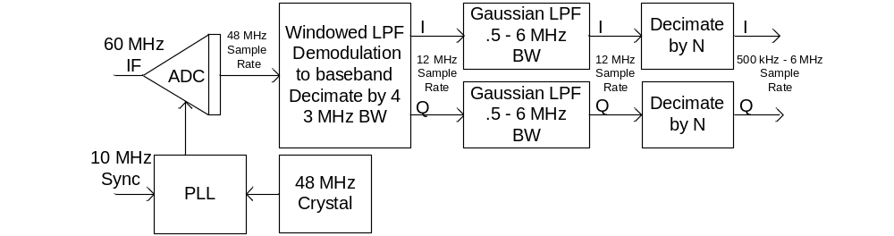
Figure(1).

The ELDORA signal processor, as seen in figure(1), implements two filters. The first filter is a Kaiser windowed polyphase decimating FIR filter. This is a low-pass filter with a pass-band on the order of 3 MHz. It also decimates the data rate by 4 reducing it from 48 MSPS to 12 MSPS. There is also a Gaussian shaped FIR filter. This filter is a single rate filter operating at 12 MSPS with bandwidths ranging from 3 MHz to 250 kHz. The data rate of the output of the Gaussian filter is then decimated to match the pulsewidth. The correlation is as follows.

Output Rate = 1 / Pulsewidth , Bandwidth = Output Rate

With the use of two filters and multiple data rates, it can be confusing as to what values to use to calculate the process gain. As long as all filtering and decimation steps do not allow noise to fold back into the bandwidth of interest, the filters can essentially be modeled as the lone narrowest band filter operating at the highest sampling frequency and data rate decimation at the output.

In the case of the ELDORA signal processor, it would simplify to the Gaussian filter bandwidth operating at 48 MSPS.

Using a 1us pulsewidth(1 MHz BW) as an example, a process gain of 13.8 dB would be added to SNR.

Undersampling

Undersampling works much the same as oversampling. The undersampling process effectively creates an image of the bandwidth of interest at a frequency within the Nyquist region, from a frequency outside the Nyquist region.

As an example, take the case of the ELDORA signal processor. An IF frequency of 60 MHz is sampled at a rate of 48 MHz. The IF is undersampled, resulting in an image located at 12 MHz. The analysis can continue as if a 12 MHz IF was sampled at 48 MHz.

FFT Gain

When using an FFT to observe the frequency spectrum of a signal, a gain is incurred by the FFT calculation. When using an M point FFT, both the signal power and noise power are spread across the M bins of the FFT. This effectively causes a drop in the system noise floor by the amount calculated using the equation below.

FFT Gain = 10 * log ₁₀ ( M / 2)

This drop in the noise floor is inherent to the FFT calculation and is not added to the system. Therefore it must be removed from the SNR measurement taken when observing the FFT plot.

Example:

By using the equation above while observing the frequency spectrum of a 1024 point FFT plot, the noise floor of the spectrum would drop by 27.1 dB. This FFT gain would be subtracted from the overall SNR to give the true SNR of the ADC with the added process gain.

SNR Calculation:

SNR can be defined as :

SNR = 10 * log ₁₀ (Signal Power / Noise Power) = 20 * log ₁₀ (RMS Signal/ RMS Noise)

and…

Signal Power = (RMS Signal)²

Noise Power = (RMS Noise)²

In order to calculate the SNR, both the Signal Power and Noise Power had to be determined. This was done by using two datasets. The first dataset was digitized while no input was provided to the processor which provided the information needed for the Noise Power. The second dataset was digitized while a full scale input (+10dB) was applied to the processor. This dataset provided the information needed for the Signal Power.

When the “no input “ dataset was analyzed in Matlab using the FFT function, the RMS Noise was calculated as follows.

RMS Noise = [ ∑ ( Magnitude of Noise ²) ] ^{½} (summed over all FFT frequency bins)

where Noise represents the magnitude of the FFT in each frequency bin of the FFT. After calculating the Square Root of the Sum of the Squares, the RMS Noise was determined. By squaring this value, the Noise Power for the system was established.

When the “full scale input” dataset was analyzed in Matlab using the FFT function, the magnitude of fundamental frequency was recorded. This magnitude served as the RMS Signal because it ideally occupies a single frequency bin of the FFT.

RMS Signal = [ ∑ ( Magnitude of Signal ²) ] ^{½} (summed over 1 FFT frequency bin)

Therefore the summation drops out yielding the following.

RMS Signal = Magnitude of the Signal

By squaring this value, the Signal Power for the system was established.

Now that the Signal Power and Noise Power of the system were determined, the SNR could be calculated using the equation above.

ELDORA Example:

This example will evaluate and confirm the process gain and of the ELDORA signal processor. For calculation purposes, all plots and calculations will be based on the following givens.

ADC = 14 bits
f_{s} = 48 MSPS
f_{input} = 60.04555 MHz
P_{in} = +10 dB (Full Scale)
Pulsewidth = 1 us
Gaussian Filter Bandwidth = 1 MHz (+/- 500 kHz)
Output Data Rate = 1 MSPS
FFT Length = 1024 Points (unless otherwise specified)

The ELDORA Signal Processor accepts a 60 MHz IF frequency that is then undersampled by the 48 MHz sample clock to produce an image of the signal at 12 MHz. The image is then demodulated down to baseband. The signal of interest will be the frequency offset from 60 MHz which in this case is 45.55 kHz.

In figures (2), (3), and (4), FFT power spectrum plots are shown along with their measured SNR. It is important to remember that the FFT plots include FFT gain which must be recognized while interpreting the plots. It may be easier to visualize if the FFT gain were subtracted from the plots.

In order to prove the effects of process gain in a system, the ADC SNR must be established first. This was done by demodulation of the input signal without filtering involved. Figure(2) shows the SNR of the demodulation scheme at 68.2 dB which was measured by the processor at the full scale input of +10 dB.

As this was a direct SNR measurement of the digitizer card, it could be directly compared to the SNR of the datasheet. The datasheet claims an SNR of around 65-70 dB depending on input frequency. Our measured value does fall within this range.

It may also be important to note that the measured SNR could be skewed due to the calculations being based on a one set sample size and not averaged.
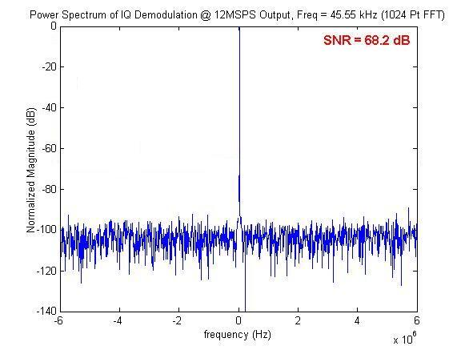
Figure(2).

At this point, filtering and downsampling were added to demodulation scheme to create the DDC of the signal processor in its entirety. With the SNR of the digitizer card established at 68.2 dB, an increase in SNR due to process gain of 16.8 dB should be expected. Figure(3) shows the SNR of the DDC scheme at 85 dB which was measured by the processor at the full scale input of +10 dB. The increase in power was as expected. The process gain was computed as follows:

Process Gain = 10 * log ₁₀ ( f_{s} / (2 * BW)) = 10 * log ₁₀ (48e6 / (2 * 500e3)) = 16.8dB
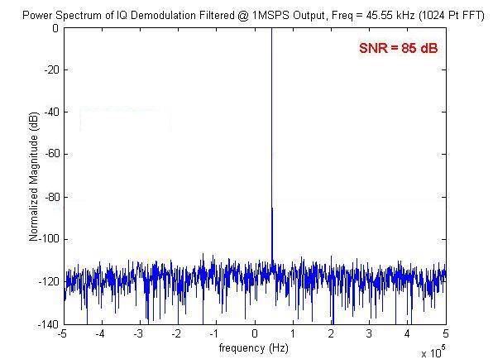
Figure(3).

In order to demonstrate the change in the noise floor due to FFT gain, figure(4) shows a 6 dB drop in the noise floor as compared to figure(3) when the same input signal is analyzed using a 4096 Point FFT instead of the 1024 Point FFT. Although there is an observed drop in the noise floor, it has no effect on the noise power. The effect is simply that the noise magnitude is reduced by a factor of 4 (-6dB) and is spread over 4 times as many FFT bins (4096 bins). Therefore the noise power is unaffected. The FFT Gain was calculated as follows:

FFT Gain = 10 * log ₁₀ (M / 2)

4096 Point FFT Gain = 10 * log ₁₀ (4096 / 2) = 33.1 dB

1024 Point FFT Gain = 10 * log ₁₀ (1024 / 2) = 27.1 dB

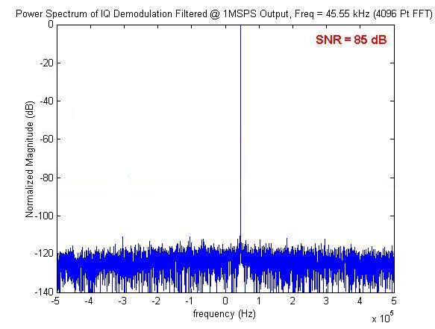
Figure(4).

